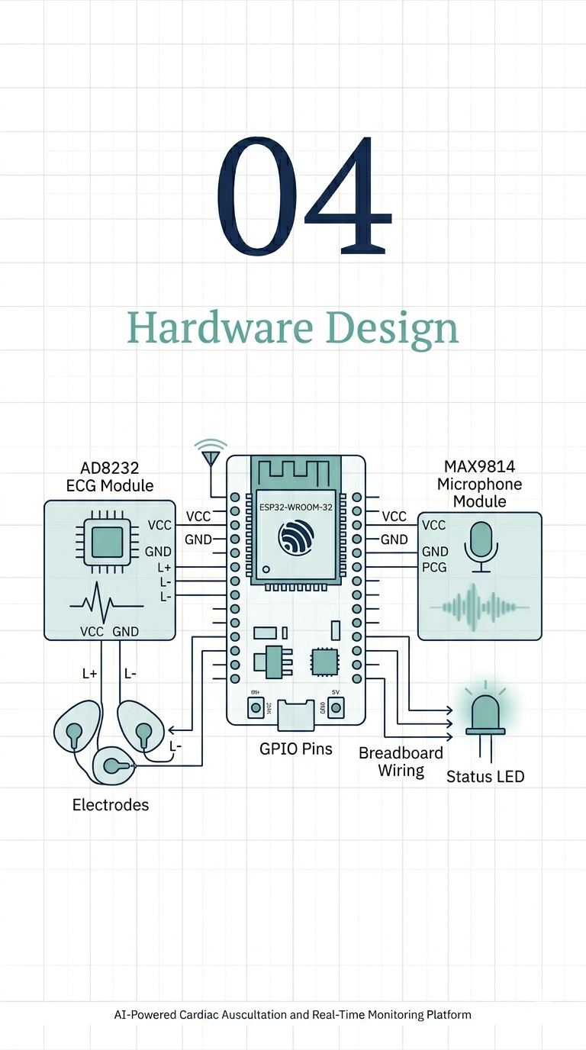

Chapter (4): Hardware Design

Hardware Objective:
Embedded Acquisition Platform Goals: The primary engineering objective of the IoT and Hardware team was to conceive and implement a compact, energy-efficient embedded acquisition platform capable of synchronously capturing both electrocardiographic and phonocardiographic waveforms, while simultaneously supporting real-time edge computing and cloud-enabled telemetry. This objective required a multidisciplinary design that integrates analog biosignal conditioning, high-frequency digital sampling, wireless connectivity, and robust embedded control within a low-cost prototype envelope. The hardware team was tasked with minimizing the barrier between raw physiological signals and actionable digital data, preserving clinical fidelity during acquisition and preprocessing, and ensuring that the device can operate reliably in a portable setting without sacrificing signal quality.
Signal Integrity and Synchronization Challenges: Designing such a system entailed significant challenges in preserving signal integrity across two distinct biomedical modalities. ECG acquisition demands a low-noise instrumentation amplifier front-end, effective common-mode rejection, and precise lead-off detection to guarantee that the cardiac electrical waveform is not corrupted by mains interference, muscle activity, or electrode impedance changes. PCG acquisition requires capturing low-amplitude acoustic vibrations from the chest wall, amplifying them with sufficient gain, and rejecting ambient noise without introducing distortion. The challenge is compounded by the requirement that both signals be sampled synchronously: ECG at 500 Hz and PCG at approximately 22.05 kHz. This dual-modality synchronization imposes stringent timing and buffering requirements on the embedded platform, and it necessitates a hardware architecture that can support concurrent analog sampling while maintaining deterministic wireless transmission.
Edge Processing and Cloud Telemetry Requirements: The system requirements therefore extend beyond simple sensing: the device must perform edge-level preprocessing, support session lifecycle control, and transmit data seamlessly to the cloud in real time. Edge processing is required to validate signal quality before streaming, to manage session metadata and heartbeat telemetry, and to avoid saturating the network with unusable data. Real-time cloud transmission is essential to preserve the continuity of patient monitoring and to enable remote analytics. Consequently, the hardware design had to balance onboard computation, analog front-end fidelity, and networking performance in a way that supports continuous physiological monitoring from the body to the cloud.

Hardware Components:

ESP32-WROOM-32:
Microprocessor Architecture and Connectivity: The chosen system-on-module is the ESP32-WROOM-32 (shown in Fig. 4.1), which provides a dual-core Xtensa® 32-bit LX6 microprocessor and an integrated 802.11 b/g/n Wi-Fi/Bluetooth radio stack. The dual-core architecture enables the firmware to partition workload effectively: one core can handle high-priority data acquisition and timer-driven sampling, while the other core can manage MQTT connectivity, JSON serialization, and session control. The module’s built-in Wi-Fi capability is essential for the project’s requirement to transmit session telemetry and waveform chunks to a cloud broker in real time, while Bluetooth remains available for future local provisioning or auxiliary control. Crucially, the ESP32 provides multiple 12-bit SAR ADC channels; the implemented design uses ADC1_CH4 on GPIO32 for ECG and ADC1_CH5 on GPIO33 for PCG. This allows direct sampling of conditioned analog outputs without external ADC hardware, preserving low system cost and minimizing board complexity.

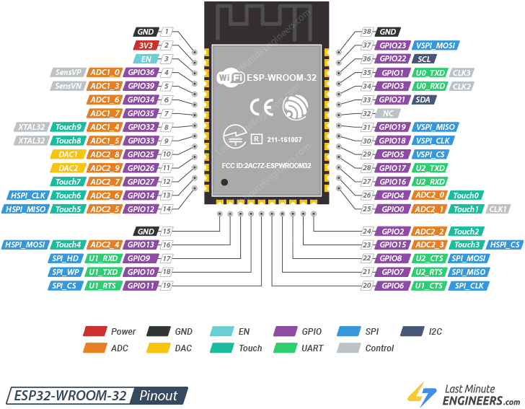
Figure 4.1: The ESP32-WROOM-32 development board, utilized as the main processing unit for dual-core data acquisition and wireless transmission.

Analog-to-Digital Conversion and Timer Configuration: The ESP32’s ADC is configured for 12-bit resolution with 11 dB attenuation to accommodate the expected voltage range of the ECG and PCG front-ends. The high sampling rate capability of the module, combined with its real-time timer peripherals, enables reliable generation of 500 Hz and 22.05 kHz sampling intervals through hardware timers. This makes the ESP32-WROOM-32 a suitable edge processor for this biomedical device, providing the necessary computational headroom for synchronous acquisition and network stack execution within a compact footprint.

AD8232 ECG Module:
For ECG acquisition, the AD8232 analog front-end module was selected because it integrates instrumentation amplifier functionality with specialized cardiac signal conditioning blocks. The AD8232 contains a low-noise instrumentation amplifier, driven-right-leg (DRL) output, high common-mode rejection ratio, and configurable gain stages that are purpose-built for monitoring single-lead ECG signals. Its integrated lead-off detection pins (LO+ and LO–) allow the firmware to detect improper electrode contact and to suppress corrupted recordings. Using the AD8232 avoided the need to design a discrete analog front-end with multiple operational amplifiers, precision resistors, and band-pass filters, which would increase design complexity and reduce reproducibility. The module’s signal conditioning is optimized for the low-amplitude, low-frequency cardiac potentials of the body, making it uniquely suited for extracting a clean ECG waveform from the noisy surface environment.
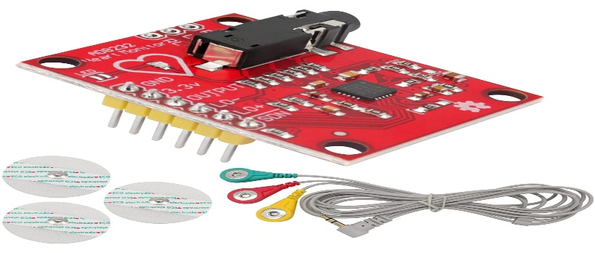
Figure 4.2: AD8232 ECG Monitor Sensor Module with Cable and Electrodes
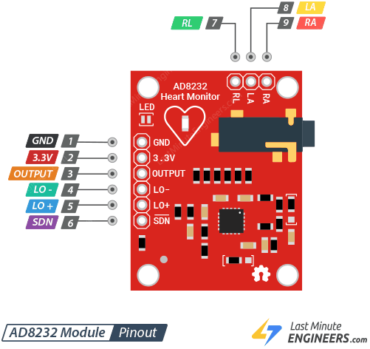
Figure 4.3: AD8232 ECG Monitor Sensor Pinout

MAX9814 Analog Microphone Module:
The PCG acquisition stage employs the MAX9814 analog microphone amplifier module. This device was chosen for its low-noise microphone preamplifier and integrated Automatic Gain Control (AGC), which is critical for stabilizing the amplitude of heart sounds across a wide dynamic range. Cardiac acoustics vary significantly in amplitude depending on auscultation location, body habitus, and breath phase; the MAX9814 AGC normalizes these variations and prevents saturation during louder heart sounds while preserving weak murmurs. The module’s analog output can be sampled directly by the ESP32 ADC, and the chosen gain configuration maximizes sensitivity for low-level phonocardiogram events. Its frequency response is compatible with the physiological frequency band of interest for PCG (approximately 20 Hz to 1 kHz), ensuring that the important heart sound components are retained while limiting unwanted high-frequency noise.

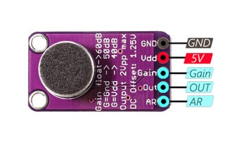
Figure 4.4: The MAX9814 analog microphone module, featuring an electret microphone and integrated AGC for capturing stable phonocardiogram (PCG) acoustics.

Auxiliary Components
- Jumper Wires: High-quality jumper wires are used to connect the sensor modules to the ESP32 and to route safely between the biosensor outputs, voltage rails, and the microcontroller. The wires must be shielded or twisted where possible to reduce electromagnetic interference and crosstalk between analog channels.
- Power Source / Battery Regulation: The device is powered from a regulated 3.3 V source derived from a stable battery or bench power supply. Because the ESP32 and the analog front-ends are sensitive to supply ripples, the design requires low-dropout regulation and sufficient decoupling capacitors at each module to maintain clean analog reference voltage and stable digital operation.
- Biomedical Electrodes: The ECG system uses standard adhesive electrodes for the patient interface, chosen for their low contact impedance and secure attachment to the skin. Proper electrode material and conductive gel are necessary to minimize motion-induced artifacts and to ensure consistent measurement of the cardiac signal.
- Microphone Acoustic Positioning: The MAX9814 microphone must be mounted in an acoustic stethoscope-like configuration with sufficient mechanical coupling to the chest wall. This requires a soft yet stable interface to the body to maximize transmission of heart sounds without introducing mechanical vibration noise.
- Structural Enclosure: The enclosure provides mechanical protection, organizes component placement, and reduces handling of artifacts. It should allow cable strain relief, isolate the patient from electronic components, and support the placement of the ESP32, power regulation circuit, and sensor modules in an ergonomic layout.

Component | Specification | Quantity | Purpose
ESP32-WROOM-32 | Dual-core 240 MHz Xtensa LX6, Wi-Fi/Bluetooth, 12-bit ADC, 4 MB flash | 1 | Edge processor, wireless connectivity, ADC acquisition
AD8232 ECG Module | Integrated instrumentation amplifier, lead-off detection, ECG signal conditioner | 1 | Analog ECG front-end for single-lead acquisition
MAX9814 Analog Microphone | Low-noise mic amplifier, AGC, analog output, 20 Hz–20 kHz bandwidth | 1 | PCG front-end amplifier for chest auscultation
Biomedical ECG Electrodes | Adhesive Ag/AgCl electrodes with lead wires | 3 | Patient contact for ECG signal capture
Jumper Wires | 20–24 AWG male/female jumper cables | 6–8 | Electrical connections between sensors and ESP32
3.3 V Voltage Regulator | Low-dropout regulator with decoupling capacitors | 1 | Stable power supply for ESP32 and sensor modules
Status Indicator LED | 5 mm LED, current-limiting resistor | 1 | Visual status indication of connectivity and streaming
Enclosure / Mounting Hardware | Plastic or 3D-printed housing, cable clamps, standoffs | 1 | Mechanical protection and ergonomic placement
Table 4.1: Hardware Bill of Materials (BOM (

Sensor Selection Rationale:
- The AD8232 was selected as the ECG analog front-end because its integrated instrumentation amplifier and cardiac-specific signal conditioning significantly reduce the design burden associated with raw operational amplifier implementations. Unlike a discrete op-amp pair, the AD8232 provides a proven instrumentation amplifier topology with a high common-mode rejection ratio (CMRR) that is essential for rejecting power line interference and common-mode noise from body-surface electrodes. Its single-ended output is already referred to as an internal amplifier stage, simplifying the subsequent ADC interface. The module includes dedicated lead-off detection pins, which are critical for rejecting corrupted ECG data when electrode contact is lost. In contrast, a raw op-amp design would require multiple precision components, careful layout to avoid offset drift, and additional filtering stages to achieve equivalent performance, making it a less practical choice for a low-cost prototype.

- The MAX9814 was chosen for the final PCG design because its integrated AGC stabilizes heart sound amplitudes that can otherwise vary by orders of magnitude due to auscultation location and patient-specific acoustic coupling. Heart sounds are inherently nonstationary, and the analog AGC in the MAX9814 ensures that the ADC input remains within the dynamic range of the ESP32 even when S1 and S2 components differ in amplitude. This functionality reduces the need for complex digital gain control and improves the robustness of the phonocardiographic signal in the presence of background noise and variable chest-wall coupling. The module’s analog output also allowed direct interfacing with the ESP32 ADC, maintaining a simple signal chain suitable for edge sampling and streaming.

- The INMP441 digital microphone was explored as an earlier prototype option during the R&D phase. It was investigated because digital MEMS microphones can offer convenient I²S outputs and simplify analog gain staging. However, the project team ultimately replaced the INMP441 with the MAX9814 analog microphone module for the final design. The INMP441 introduced additional complexity in timing, bus configuration, and digital interface management, while also being more sensitive to electromagnetic interference from the ESP32’s wireless subsystem. The analog MAX9814 design provided a more direct, lower-latency, and acoustically stable solution for PCG capture within the existing ADC-based architecture.

Wiring and Pin Mapping
The physical interface layout of the prototype is defined by direct analog connections between the sensor modules and the ESP32 analog inputs, along with a single status LED for system feedback.
- The AD8232 ECG module is powered from the 3.3 V regulated supply and shares the common ground with the ESP32.
- The AD8232 OUT pin is connected to GPIO32 on the ESP32, which maps to ADC1_CH4 and is configured for 12-bit analog sampling.
- The AD8232 leads-off detection pins are connected to GPIO34 and GPIO35, allowing the firmware to monitor electrode contact continuity and suppress invalid ECG segments. These pins are dedicated inputs that sense whether the patient leads remain attached, supporting safety and data quality.
- The MAX9814 microphone module likewise receives 3.3 V power from the same regulator and references the same ground plane to minimize common-mode differences.
- The MAX9814 analog OUT pin is connected to GPIO33 on the ESP32, which maps to ADC1_CH5 and is sampled at a high rate of approximately 22.05 kHz.
- The MAX9814 GAIN pin is intentionally tied to ground, which configures the amplifier for its maximum gain setting (nominally 60 dB) to maximize sensitivity to heart sound energy.
- The A/R (attack/release) pin is left floating, allowing the module to use its default AGC timing characteristics optimized for slowly varying acoustic amplitudes.
- A status indicator LED is connected to GPIO2 on the ESP32. This on-board LED is used by the firmware to convey system states such as Wi-Fi/MQTT connection, active streaming, and error conditions through controlled blink patterns. The LED is an important human-interface element for prototype validation during hardware deployment.
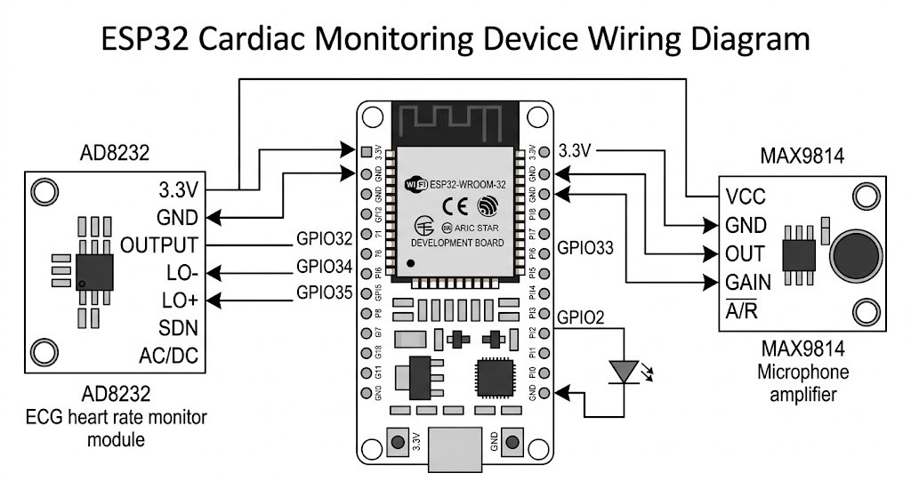
Figure 4.5: Hardware wiring diagram illustrating the specific pin connections between the ESP32-WROOM-32 microcontroller, the AD8232 ECG analog front-end, and the MAX9814 PCG microphone module.

Table 4.2: ESP32 Pin Mapping and Peripheral Configuration
Source Component | Sensor Pin | ESP32 GPIO | Function / Signal Type
AD8232 ECG Module | VCC | 3.3 V rail | Power supply
AD8232 ECG Module | GND | Common ground | Reference ground
AD8232 ECG Module | OUT | GPIO32 (ADC1_CH4) | ECG analog voltage output
AD8232 ECG Module | LO+ | GPIO34 | Lead-off detection positive
AD8232 ECG Module | LO– | GPIO35 | Lead-off detection negative
MAX9814 Microphone Module | VCC | 3.3 V rail | Power supply
MAX9814 Microphone Module | GND | Common ground | Reference ground
MAX9814 Microphone Module | OUT | GPIO33 (ADC1_CH5) | PCG analog voltage output
MAX9814 Microphone Module | GAIN | Ground | Maximum gain configuration
MAX9814 Microphone Module | A/R | Floating | Default AGC attack/release behavior
Status Indicator LED | Anode/Cathode | GPIO2 | Visual status indicator

Custom Printed Circuit Board (PCB) and Power Management
PCB Integration and Signal Integrity: To transition the hardware from an initial proof-of-concept to a robust, deployable medical prototype, a custom Printed Circuit Board (PCB) was designed. This custom layout minimizes parasitic capacitance and inductance inherent in breadboard wiring, providing a mechanically stable foundation for the ESP32-WROOM-32, the AD8232 ECG analog front-end, and the MAX9814 PCG microphone. By physically routing sensitive analog traces away from the high-frequency Wi-Fi antenna and digital switching lines, the PCB significantly improves the overall Signal-to-Noise Ratio (SNR) for both cardiac modalities.
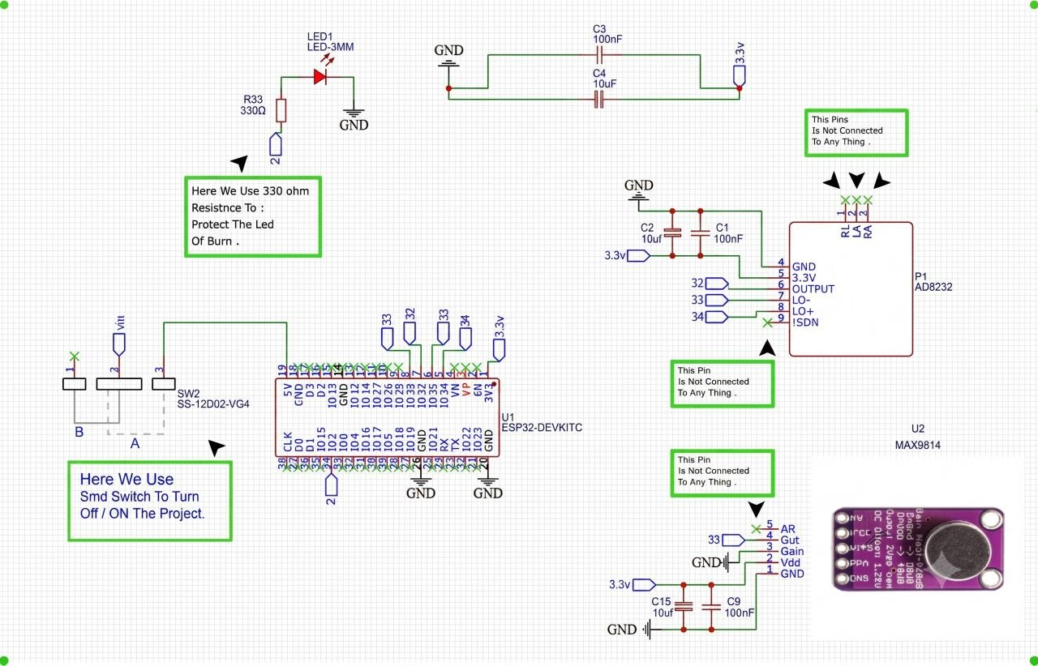
Figure 4.2: Schematic diagram illustrating the hardware integration of the ESP32-WROOM-32 microcontroller with the AD8232 ECG and MAX9814 PCG analog front-ends.

Battery Charging and Protection Circuitry: The PCB incorporates a dedicated power management architecture to support portable ambulatory monitoring. A TP4056 lithium-ion battery charge controller is utilized to safely regulate the charging cycle via a modern USB Type-C interface. To ensure battery longevity and operational safety, a DW01A battery protection IC is paired with an FS8205 dual N-channel MOSFET. This protection sub-circuit continuously monitors the battery cell, disconnecting the load in the event of over-charge, over-discharge, or short-circuit conditions.

Load Sharing Power Path Control: To guarantee uninterrupted physiological monitoring, the design features an intelligent load-sharing power path controller. Implemented using an AO3401 P-channel MOSFET and an SS34 Schottky diode, this circuit automatically multiplexes the system's power source. When USB power is connected, the system is powered directly from the external source while the battery charges independently. Upon USB disconnection, the MOSFET seamlessly switches the system load to the battery, preventing voltage drops or microcontroller resets during active streaming sessions.
Decoupling and Hardware Noise Mitigation: Addressing the power supply stability limitations, strategic capacitive decoupling was implemented across the PCB. Small 0.1 µF ceramic capacitors were placed intimately close to the power pins of the AD8232 and MAX9814 to shunt high-frequency electromagnetic noise to the ground plane. Additionally, larger 10 µF capacitors were utilized as local energy storage tanks to smooth out transient voltage spikes and mitigate the sudden voltage droop caused by the ESP32's high-current Wi-Fi transmission bursts. This filtering ensures that the analog reference voltage remains rock-steady, preventing transmission-induced artifacts in the sensitive ECG and audio signals.
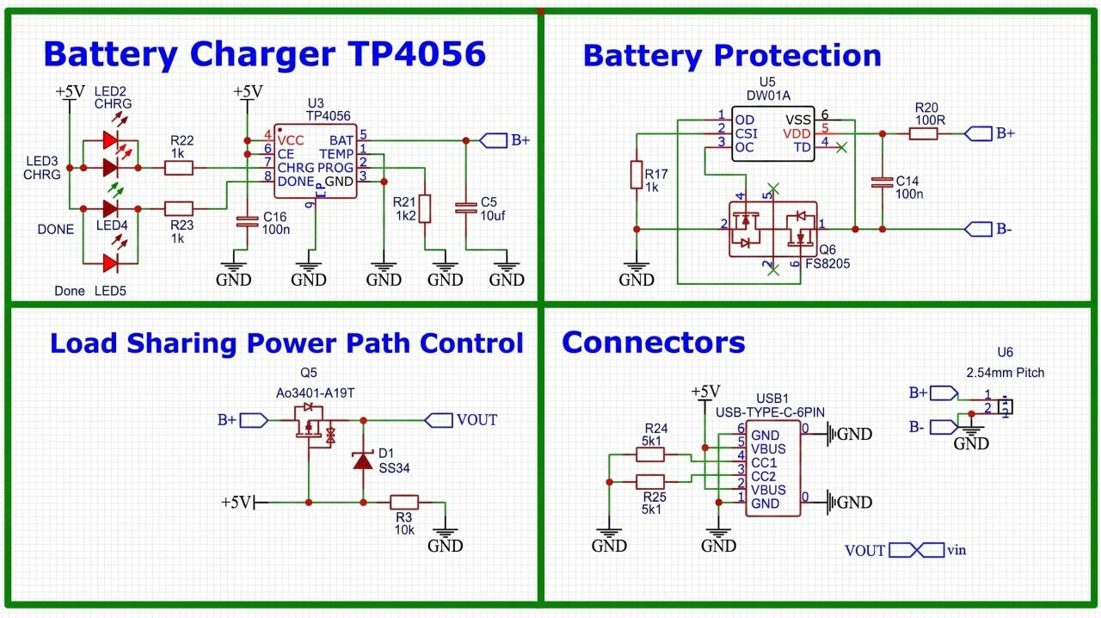
Figure 4.3: Schematic diagram of the custom PCB power management circuitry, featuring the TP4056 charging module, DW01A battery protection, and the automated load-sharing power path.

Physical Assembly and Placement
ECG Electrode Configuration and Skin Preparation: For practical deployment, the physical assembly guidelines emphasize both signal quality and patient safety. The ECG electrodes are placed in a standard three-lead configuration on the patient’s body. In this configuration, one electrode is attached to the right arm region, one to the left arm region, and one to the left leg or lower abdominal region. This arrangement provides a stable lead vector for single-lead ECG acquisition and maximizes the amplitude of the QRS complex while reducing the potential for baseline wander. Proper skin preparation, including cleaning and abrasion, is necessary to lower skin impedance and improve electrode adhesion. Secure electrode placement mitigates the risk of lead-off events and minimizes motion artifacts due to patient movement.
PCG Acoustic Sensor Positioning: The microphone placement is selected to maximize acoustic coupling of cardiac sounds while reducing ambient noise. The PCG sensor is positioned at established auscultation points on the anterior chest wall, such as the left sternal border at the fourth intercostal space for tricuspid and pulmonary sounds, and the midclavicular line at the fifth intercostal space for mitral sounds. These acoustic locations are empirically chosen to capture the fundamental S1 and S2 components of the heart cycle with the highest signal-to-noise ratio. The microphone module should be mechanically coupled to the chest via a soft acoustic interface or stethoscope-like pad to ensure stable contact and to suppress mechanical vibrations from respiration and body movement.
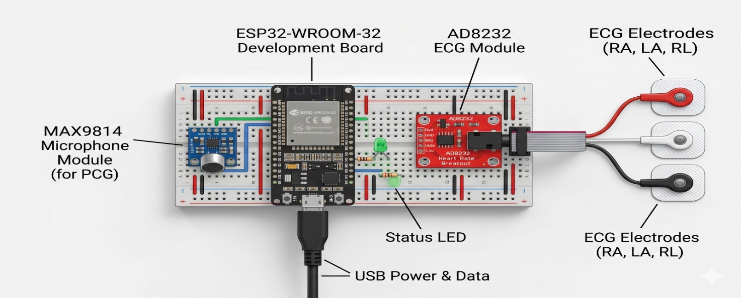

Figure 4.2: Rendered hardware layout of the prototype assembly, illustrating the physical integration of the ESP32 microcontroller, the AD8232 ECG module with its 3-lead electrode configuration, and the MAX9814 microphone for PCG acquisition.

Mechanical Stability and Electrical Safety: System stability is addressed through mechanical design choices that minimize artifact sources. Cable strain relief is implemented at the point where the electrode and microphone leads exit the enclosure, preventing bending or tugging forces from transmitting to the sensor interfaces. The enclosure is designed to hold the ESP32 module, analogue front-end boards, and the power regulation components in a compact layout with sufficient clearance for airflow and connector access. Ergonomic considerations include routing cables so they do not impede the patient’s posture and using a lightweight housing that can be secured without causing discomfort. Electrical safety is maintained by ensuring that all exposed conductive parts are isolated from the patient and that the ground reference is common and stable across the device.

Hardware Limitations
- Analog Noise Interference: The current hardware implementation has several important engineering limitations that define its boundary relative to clinical-grade diagnostic equipment. Analog noise interference remains a significant challenge: the device relies on the ESP32’s internal 12-bit ADC and on discrete sensor modules that are susceptible to electromagnetic coupling from radio-frequency emissions, mains hum, and switching noise from the power supply. Although the AD8232 provides high common-mode rejection, the overall system can still exhibit low-amplitude noise that degrades the fidelity of the ECG waveform, especially in the presence of imperfect electrode contact.

- Motion Artifacts and Baseline Wander: Motion artifacts are another limitation that directly affect electrode contact quality. The reliance on adhesive electrodes and external lead wires creates a mechanical interface that is sensitive to patient motion, breathing, and muscle contractions. These artifacts manifest as baseline wander, transient spikes, and pseudo-QRS complexes, and they limit the reliability of long-term ambulatory monitoring without additional motion compensation or adaptive filtering.

- Acoustic Coupling and Environmental Noise: For the phonocardiogram pathway, acoustic coupling and background noise impose practical limits on signal clarity. The MAX9814 microphone module captures chest-wall vibrations, but it is also sensitive to ambient sounds, clothing rustle, and respiratory noise. The analog AGC improves amplitude stability, but it cannot completely compensate for poor stethoscope placement or for strong noise sources in the environment. This means that the PCG signal quality is highly dependent on careful microphone placement and patient cooperation.

- Power Supply Stability and Voltage Droop: Power supply stability is another critical hardware boundary. The entire system is powered from a 3.3 V regulator, and any ripple or transient on this rail can modulate the ADC reference and introduce measurement error in both ECG and PCG channels. The ESP32 itself has high instantaneous current demands during Wi-Fi transmission, which can create voltage droop if the power source is not properly decoupled and regulated. Consequently, the device requires a robust power delivery network and sufficient local capacitance to maintain stable analog sampling during wireless activity.

- ADC Resolution and Non-linearity: The ESP32’s 12-bit ADC resolution and inherent non-linearity also constrain the device’s quantitative accuracy. While 12-bit sampling provides 4096 discrete levels, this resolution is modest compared to clinical-grade ADC systems with 16-bit or 24-bit performance. Non-linearity and channel gain error in the ESP32’s ADC can introduce distortion, especially near the extremes of the input range. This limitation is acceptable for prototype-level monitoring and qualitative waveform analysis, but it restricts the device’s ability to perform high-precision diagnostic measurements such as subtle ST-segment changes or low-amplitude heart sound spectral analysis.
- Prototype Boundaries and Future Validation: In closing, this low-cost prototype is engineered to provide a functional real-time monitoring platform and a foundation for future refinement. However, it is not equivalent to clinical-grade diagnostic equipment. Its analog front-end, sampling architecture, and mechanical implementation are designed for research and early-stage monitoring rather than for definitive clinical diagnosis. The device defines a clear boundary between an accessible biomedical engineering prototype and a regulated medical instrument, highlighting the need for further validation, shielding, and precision upgrade before deployment in a clinical diagnostic workflow.

